LAB 05

**Xây dựng bảng định tuyến cho Fat Tree và ngẫu nhiên cặp nguồn đích**

Bài làm dựa trên mã nguồn <https://github.com/bkhnk48/SSiNET/tree/master/java/custom/fattree>

Mã nguồn: <https://github.com/dranhclub/Omnetpp-project/tree/master/Lab%2005/Source>

Kết quả:

topology:

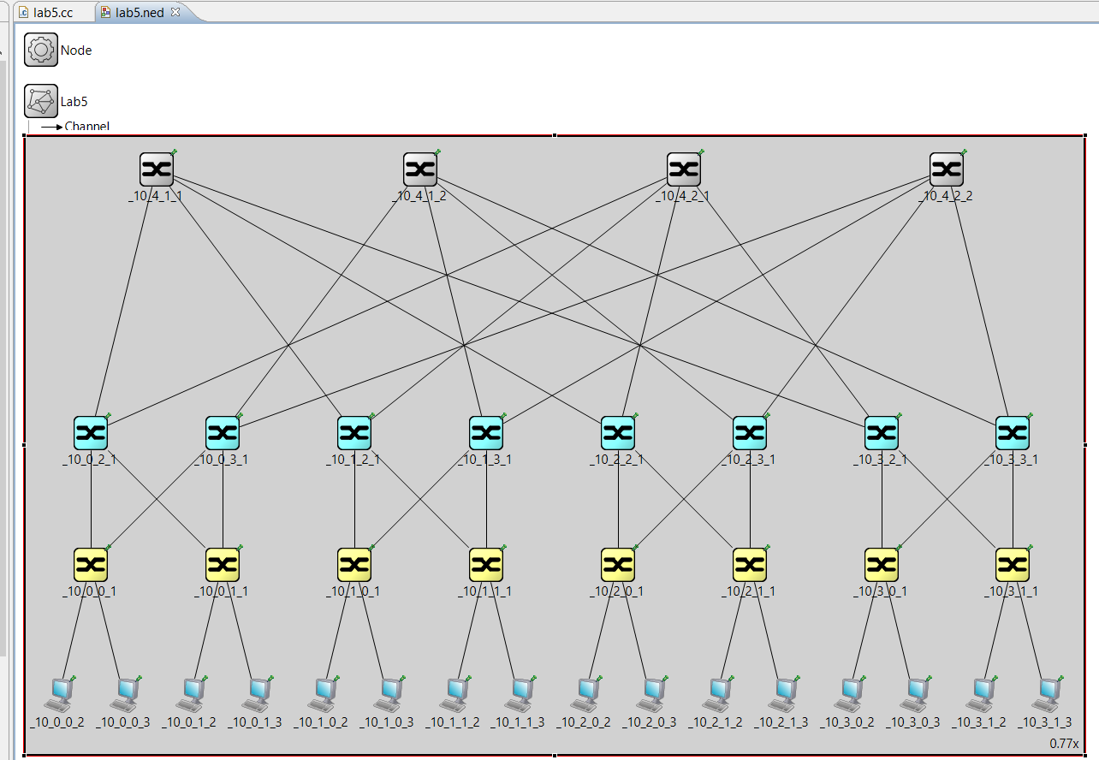

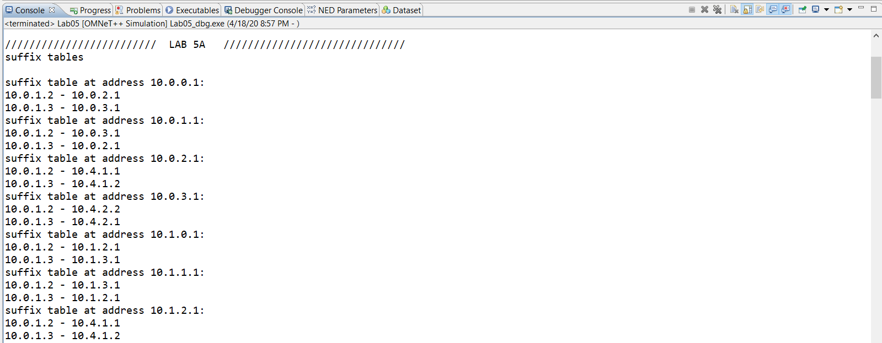

...

///////////////////////// LAB 5A //////////////////////////////

suffix tables

suffix table at address 10.0.0.1:

10.0.1.2 - 10.0.2.1

10.0.1.3 - 10.0.3.1

suffix table at address 10.0.1.1:

10.0.1.2 - 10.0.3.1

10.0.1.3 - 10.0.2.1

suffix table at address 10.0.2.1:

10.0.1.2 - 10.4.1.1

10.0.1.3 - 10.4.1.2

suffix table at address 10.0.3.1:

10.0.1.2 - 10.4.2.2

10.0.1.3 - 10.4.2.1

suffix table at address 10.1.0.1:

10.0.1.2 - 10.1.2.1

10.0.1.3 - 10.1.3.1

suffix table at address 10.1.1.1:

10.0.1.2 - 10.1.3.1

10.0.1.3 - 10.1.2.1

suffix table at address 10.1.2.1:

10.0.1.2 - 10.4.1.1

10.0.1.3 - 10.4.1.2

suffix table at address 10.1.3.1:

10.0.1.2 - 10.4.2.2

10.0.1.3 - 10.4.2.1

suffix table at address 10.2.0.1:

10.0.1.2 - 10.2.2.1

10.0.1.3 - 10.2.3.1

suffix table at address 10.2.1.1:

10.0.1.2 - 10.2.3.1

10.0.1.3 - 10.2.2.1

suffix table at address 10.2.2.1:

10.0.1.2 - 10.4.1.1

10.0.1.3 - 10.4.1.2

suffix table at address 10.2.3.1:

10.0.1.2 - 10.4.2.2

10.0.1.3 - 10.4.2.1

suffix table at address 10.3.0.1:

10.0.1.2 - 10.3.2.1

10.0.1.3 - 10.3.3.1

suffix table at address 10.3.1.1:

10.0.1.2 - 10.3.3.1

10.0.1.3 - 10.3.2.1

suffix table at address 10.3.2.1:

10.0.1.2 - 10.4.1.1

10.0.1.3 - 10.4.1.2

suffix table at address 10.3.3.1:

10.0.1.2 - 10.4.2.2

10.0.1.3 - 10.4.2.1

---------------------------------

prefix tables

prefix table at address 6:

10.0.0.0 - 10.0.0.1

10.0.1.0 - 10.0.1.1

prefix table at address 7:

10.0.0.0 - 10.0.0.1

10.0.1.0 - 10.0.1.1

prefix table at address 14:

10.1.0.0 - 10.1.0.1

10.1.1.0 - 10.1.1.1

prefix table at address 15:

10.1.0.0 - 10.1.0.1

10.1.1.0 - 10.1.1.1

prefix table at address 22:

10.2.0.0 - 10.2.0.1

10.2.1.0 - 10.2.1.1

prefix table at address 23:

10.2.0.0 - 10.2.0.1

10.2.1.0 - 10.2.1.1

prefix table at address 30:

10.3.0.0 - 10.3.0.1

10.3.1.0 - 10.3.1.1

prefix table at address 31:

10.3.0.0 - 10.3.0.1

10.3.1.0 - 10.3.1.1

---------------------------------

core prefix tables

core prefix table at address: 10.4.1.1:

10.0.0.0 - 10.0.2.1

10.1.0.0 - 10.1.2.1

10.2.0.0 - 10.2.2.1

10.3.0.0 - 10.3.2.1

core prefix table at address: 10.4.1.2:

10.0.0.0 - 10.0.2.1

10.1.0.0 - 10.1.2.1

10.2.0.0 - 10.2.2.1

10.3.0.0 - 10.3.2.1

core prefix table at address: 10.4.2.1:

10.0.0.0 - 10.0.3.1

10.1.0.0 - 10.1.3.1

10.2.0.0 - 10.2.3.1

10.3.0.0 - 10.3.3.1

core prefix table at address: 10.4.2.2:

10.0.0.0 - 10.0.3.1

10.1.0.0 - 10.1.3.1

10.2.0.0 - 10.2.3.1

10.3.0.0 - 10.3.3.1

---------------------------------

///////////////////////// LAB 5B //////////////////////////////

Danh sach host:

10.1.1.2

10.1.0.3

10.3.0.2

10.3.0.3

10.1.1.3

10.2.1.3

10.2.0.2

10.0.1.3

10.0.0.3

10.2.0.3

10.1.0.2

10.0.0.2

10.0.1.2

10.3.1.2

10.2.1.2

10.3.1.3

Ghep cap ngau nhien:

10.1.0.3 - 10.1.1.2

10.3.0.3 - 10.3.0.2

10.2.1.3 - 10.1.1.3

10.0.1.3 - 10.2.0.2

10.2.0.3 - 10.0.0.3

10.0.0.2 - 10.1.0.2

10.3.1.2 - 10.0.1.2

10.3.1.3 - 10.2.1.2

///////////////////////// LAB 5C //////////////////////////////

Routing path of 10.1.0.3 -> 10.1.1.2 :

10.1.0.3 -> 10.1.0.1 -> 10.1.2.1 -> 10.1.1.1 -> 10.1.1.2

Routing path of 10.3.0.3 -> 10.3.0.2 :

10.3.0.3 -> 10.3.0.1 -> 10.3.0.2

Routing path of 10.2.1.3 -> 10.1.1.3 :

10.2.1.3 -> 10.2.1.1 -> 10.2.2.1 -> 10.4.1.2 -> 10.1.2.1 -> 10.1.1.1 -> 10.1.1.3

Routing path of 10.0.1.3 -> 10.2.0.2 :

10.0.1.3 -> 10.0.1.1 -> 10.0.3.1 -> 10.4.2.2 -> 10.2.3.1 -> 10.2.0.1 -> 10.2.0.2

Routing path of 10.2.0.3 -> 10.0.0.3 :

10.2.0.3 -> 10.2.0.1 -> 10.2.3.1 -> 10.4.2.1 -> 10.0.3.1 -> 10.0.0.1 -> 10.0.0.3

Routing path of 10.0.0.2 -> 10.1.0.2 :

10.0.0.2 -> 10.0.0.1 -> 10.0.2.1 -> 10.4.1.1 -> 10.1.2.1 -> 10.1.0.1 -> 10.1.0.2

Routing path of 10.3.1.2 -> 10.0.1.2 :

10.3.1.2 -> 10.3.1.1 -> 10.3.3.1 -> 10.4.2.2 -> 10.0.3.1 -> 10.0.1.1 -> 10.0.1.2

Routing path of 10.3.1.3 -> 10.2.1.2 :

10.3.1.3 -> 10.3.1.1 -> 10.3.3.1 -> 10.4.2.2 -> 10.2.3.1 -> 10.2.1.1 -> 10.2.1.2

End.